Module 06 – Transshipment Problem

Exploratory Data Analysis

*In this section, you should perform some data analysis on the data provided to you. Please format your findings in a visually pleasing way and please be sure to include these cuts:*

* *Make a visual graph of your data like what we saw for the sample problem*
  + <https://excalidraw.com>
  + <https://mermaid.live>
  + <https://dreampuf.github.io/GraphvizOnline>
  + Powerpoint

Model Formulation

*Write the formulation of the model into here prior to implementing it in your Excel model. Be explicit with the definition of the decision variables, objective function, and constraints.*

*Hint: This one differs a bit from the sample problem in terms of Balance-of-Flow*

MIN = 37x03+27x05+25x08+30x15+39x23+34x24+39x25+37x26+38x+27+48X46+49x54+30x57+34x65+27x67+29x73+42x75+35x78

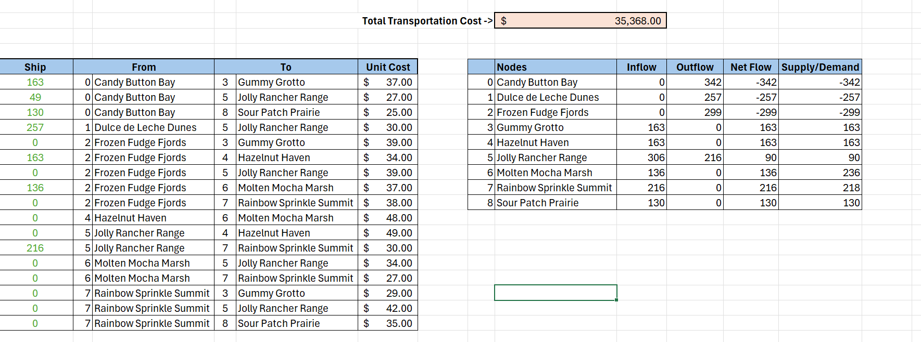

Model Optimized for Minimal Transportation Cost

*Implement your formulation into Excel and be sure to make it neat. This section should include:*

* *A text explanation of what your model is recommending*
* *Update your graph from the EDA section to bold/color the links being used (and show how much is going through that link)*

Model with Stipulation

*Please copy the tab of your original model before continuing with the next part to avoid messing up your original solution.*

*Follow these steps to complete this section:*

1. *Describe the necessity of the Balance-of-Flow for this problem type*
2. *What happens when you change your model to make Total Supply > Total Demand (i.e. add 115 units to one of the sources)*
3. *What happens when you rerun your model?*
4. *What do you need to change to make your model work again?*
5. *Make the changes and report on your findings.*
   1. *PS there is a small chance that the source you added 115 to may make your model infeasible. If so, add the 115 units to a different source.*